**Leader Overview**

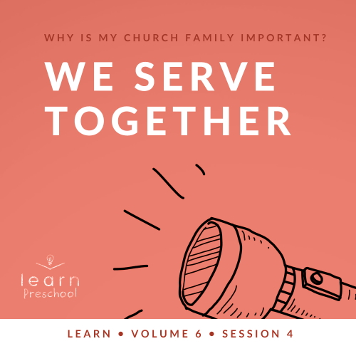

**Volume Overview**

**Why is my church family important?**

*When we think of church, it’s easy for our mind to be instantly drawn to the building where we attend. However, in God’s design, the church isn’t the building that we gather in. Instead, church has everything to do with the people who are gathered there. In essence, the biblical church is not a building that we go to, but a family of believers that we belong to*.

*As our Father, God’s heart is to adopt us into His family (*[*Ephesians 1:5*](https://ref.ly/logosref/Bible.Eph1.5)*). When we choose to put our faith in Jesus, we instantly join God’s family. We not only belong to Him but we also belong to each other. Just like our natural families here on earth were meant to function, God uses our church family to meet our needs. A healthy church family offers love, encouragement, guidance, and accountability. As the family of God—the Church—we grow together, celebrate together, share together, and even serve together. As we make a commitment to God’s family, we will become stronger, more devoted followers of Jesus*.

**Session Overview**

**We Serve Together**

*In this* **Learn** *session, preschoolers will discover the importance of serving. Throughout the Bible, we see people serving both God and each other. In the New Testament, a young boy served others by offering what he had to Jesus. Then, Jesus modeled serving when He fed the crowd. Kids will learn at a very young age that God’s family is committed to serving each other and the rest of the world*.

**Bible Lesson**

Disciples Serve the Crowd

[John 6:1–15](https://ref.ly/logosref/Bible.Jn6.1-15)

**Faith Fact**

We serve together.

**Faith Verse**

[Matthew 18:20](https://ref.ly/logosref/Bible.Mt18.20) (NLT)

“For where two or three gather together as my followers, I am there among them.”

**Preparing for the Session**

**Leader Preparation Time: 20–25 Minutes**

|  |
| --- |
| ***You Will Need***  ***Preservice Activities***  *• One glove used in performing tasks (gardening, work, latex, etc.)*  *• Toys*  *• Oyster and fish-shaped crackers*  ***Large Group***  *• Bible*  *• Worship songs (Song suggestions: “Jesus Loves Me” (remix) by Listener Kids; “The Lord Is My Rock” by Freedom Kids; “Nothing Is Impossible” by PlanetShakers Kids)*  *• For groups not using a phone or tablet only, add:*  *• Projector or TV*  *• Laptop*  *•* ***Faith Fact Sound*** *video (bell ringing)*  *•* ***Faith Fact Slide***  *•* ***Faith Verse Slide***  *•* ***Bible Lesson Video A***  *•* ***Bible Lesson Video B***  ***Small Group***  *•* ***Small Group Activity Page****, one per kid*  *• Crayons, markers, or colored pencils*  *•* ***Small Group Feet-to-Floor Game Pages*** *1–3*  *• Scissors*  *• Optional: Two small baskets or buckets*  *• Bowl*  *• Water*  *• Ground black pepper*  *• Liquid dish soap*  *To access session content and videos from a computer, visit:* [*BibleEngagementProject.com/downloads*](https://bibleengagementproject.com/downloads) |
| ***Getting Ready***  ***Preservice Activities***  *• Set out toys and snacks.*  ***Large Group***  *• Download videos and slides if needed.*  *• Select worship song(s) and have them ready to play.*  ***Small Group***  *• Print copies of the* ***Small Group Activity Page****, one per kid*  *• Print the* ***Small Group Feet-to-Floor Game Pages****, two sets per group.*  *• Cut apart the fish pictures.*  *• Watch this video ahead of time:* [*https://www.youtube.com/watch?v=ho0o7H6dXSU*](https://www.youtube.com/watch?v=ho0o7H6dXSU)  *• Fill the bowl with water.*  *First time leading* Learn *for Preschool? Check out the* [Facilitator Guide](https://0b769b0ed3569ef9d18b-f88d8272f61086866d50d048b43ef630.ssl.cf2.rackcdn.com/sites/biblengagementproject/Listen_Facilitator_Guide.pdf). |

**Preservice Activities**

*See what’s needed at the beginning of the session.*

**Bible Story Warm-Up**

*As kids enter, have them sit in a circle*.

*(Hold up the glove.)* Does anyone know what this is? *(Group response)* That’s right! It’s a glove. Raise your hand if you have ever worn a glove when it’s cold outside. *(Group response)* Have you ever had to wear a glove when it wasn’t cold outside? *(Group response)* What were you doing? *(Allow responses.)* When I’ve used a glove like this, it’s usually because I’ve been working. Sometimes when I’m working, I get to help other people.

• *Ask these questions:*

Do you enjoy helping others?

What is a way you can help someone?

How do you feel after you help someone?

You all have some great ideas of how you can help others. When we help someone, we put their needs first. Serving is another way to say we helped someone. We’re going to spend a lot of time learning about serving today.

**Snack**

**Oyster and Fish-Shaped Crackers**

*As kids are eating the snack, share the following:*

Our snack time today is a great time to practice serving others. Who’d like to help?

• *Choose kids to help with different jobs: hand out snack and drinks, pick up trash, etc*.

Remember, when someone serves you, be sure to thank them. God wants us to serve others and to be thankful when we’re served. Is it easy for you to remember to say thank you when someone serves you? *(Allow responses.)* I love to see you serve each other. I can’t wait to keep learning about serving with you.

**Free Play**

*Any extra time can be spent playing with toys*.

**Transition**

*A few minutes before service begins have kids make their way to the large group area and sit in their designated areas*.

**Large Group**

**25 Minutes**

*See what’s needed at the beginning of the session.*

**Introduction**

Hey, my friends! I have a super fun time planned as we learn from God’s Word today. *(Hold up the Bible.)* If you’re excited to learn from the Bible, stomp your feet three times. *(Group response)*

Do you think the Bible tells stories about kids helping people? *(Group response)* You’re right! It does. When we help someone, we put their needs first. Today, we’ll hear about a time when a young boy helped Jesus. Then, Jesus and His disciples served a lot of people. Serving is another way to say helping. We can learn how to serve others from this Bible story. Sometimes serving people can seem like hard work. That’s why we need to remember what Jesus shows us about serving.

**Faith Fact**

Serving others can be a lot of fun, especially when we do it together. That’s why our Faith Fact is **We serve together**.

• *Show the* ***Faith Fact Slide***.



Stand up on your feet, and let’s say it together. **We serve together**. Now, let’s jump once with each word. Ready for three jumps? **We serve together**. Let’s try it again, but this time high-five someone when we finish. Ready? **We serve together**.

**Bible Time**

As you sit down, I want you to think about something. What are some of the best ways to learn how to serve others? *(Allow responses.)* Great answers! We can watch others to learn from them. Jesus is the best Person to learn from. *(Hold up the Bible.)* The Bible is the best place to find out how He served others. Let’s find out how a young boy helped Jesus. If you’re ready to check in with Lizzy for today’s Bible story, say, “Let’s go!” *(Group response)*

• *Play* ***Bible Lesson Video A***.

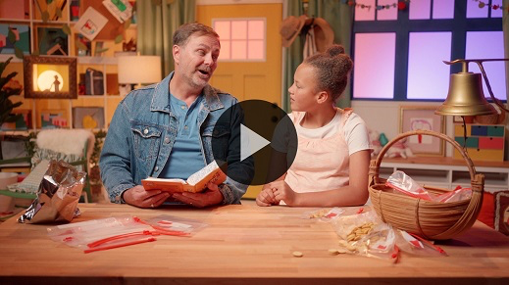

You did such a great job helping Lizzy solve those clues. What was your favorite part of today’s story? *(Allow responses.)* Those are all so great!

It’s so cool how Lizzy always takes what she learns and shares it with us. In our story today, who shared a lunch? *(Allow responses.)* That’s right! A boy shared his lunch. Jesus loves it when grown-ups and kids like you share things and serve others.

What happened after Jesus prayed and blessed the boy’s food? *(Allow responses.)* An amazing miracle happened! Jesus took a little fish and bread, and made it feed a big group of people. Jesus made a little into a lot. It’s amazing what God can do when we give Him what we have. He can help us use it to serve others.

Everyone in the Bible story served together to feed the crowd. The young boy offered to give his lunch. Jesus prayed and blessed it. Then, the disciples handed out the food ([Luke 9:16](https://ref.ly/logosref/Bible.Lk9.16)). It must have been so cool for the boy and the disciples to be part of such an amazing miracle.

**Worship**

Let’s thank God for doing amazing miracles as we worship Him. Let’s put our full attention on God and put anything else out of our mind.

**Praise**

Are you thankful God can do miracles? Jump up high. *(Group response)*

Do you want God to help you to serve others? Spin around. *(Group response)*

Who’s ready to show God you love Him? Wave your hands up high. *(Group response)*

**Sing**

Let’s do that now as we sing and worship God. Let’s thank Him for who He is and all He has done. Let’s sing together.

• *Lead the kids in singing one or two songs. See song suggestions at the beginning of the session*.

**Prayer**

Wow, that was amazing! It’s so great to get to worship God with you. I love when we can praise God together. Let’s continue to focus on God as we pray. Let’s each one bow our head and talk to God.

|  |
| --- |
| Dear God, thank You for loving me. Thank You for showing me how Jesus served others to share Your love with them. Help me to serve others and point them to You. Amen. |

**Bible Time cont’d**

Our Faith Verse tells us how important it is to be with other people who follow Jesus. I love the promise God gives us in this verse. Let’s check back in with Lizzy to say our Faith Verse together.

• *Play* ***Bible Lesson Video B***.

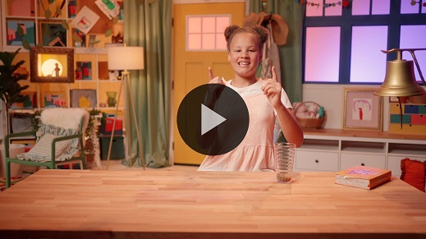

That’s great! You’ve been working so hard to learn our Faith Verse. God is excited when we take time to learn His Word because that means we’re learning more about how to live for Him. The Bible is filled with so much for us to learn.

**Response Time**

• *Play a worship song quietly*.

Now, let’s take some time to respond to God about what we’ve learned today. When we respond, we pause to think about what we’ve heard. Then, we talk to God about it. Today, we heard that we can serve together. Let’s ask God to help us do that now.

• *Optional: Have the kids repeat phrases of the prayer after you*.

|  |
| --- |
| Dear God, thank You for the miracle that Jesus did with a boy’s lunch. I want to be like Jesus. Help me to follow Him by serving others. Amen. |

**Faith Verse**

We can always learn more from God’s Word. Let’s say our Faith Verse and do the actions together.

[Matthew 18:20](https://ref.ly/logosref/Bible.Mt18.20) (NLT)

“For where two or three gather together as my followers, I am there among them.”

• *Show the* ***Faith Verse Slide***.

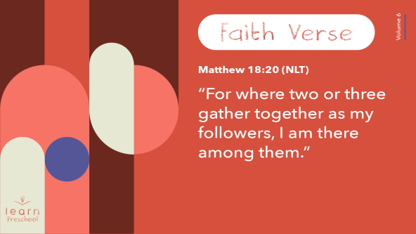

You kids are terrific! You’ve done a great job learning the Faith Verse. I’m so proud of you.

**Closing**

Who is having fun learning from God’s Word today? *(Group response)* It’s been so great worshipping, singing, and praying together. We even practiced our Faith Verse. Our Bible story was packed with people serving others, and that makes me so excited to serve others.

• *Play the* ***Faith Fact Sound*** *video (bell ringing)*.

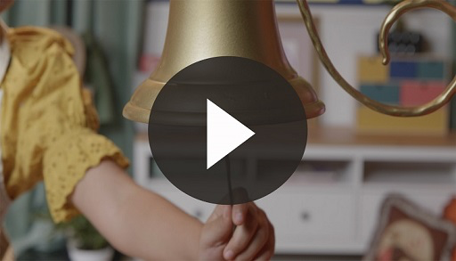

Did you hear that? It’s the sound that means it’s time to say our Faith Fact one more time. **We serve together**.

• *Show the* ***Faith Fact Slide***.



Let’s shout it together. Ready? **We serve together.** Now, let’s say it as fast as we can. Ready? **We serve together**. Now let’s say it slowly. **We serve together**.

**Dismissal to Small Groups**

It’s time to go to our circles. Now, let’s keep having fun as we learn more about serving others.

• *Dismiss the kids by groups*.

|  |
| --- |
| ***Leader Tip:*** *This can be done by assigning color teams or by age groups. Note that some young preschoolers may not know their age. Using a colored sticker, jersey, or wristband will help separate the kids and help identify their small groups.* |

**Small Group**

**25 Minutes**

*See supplies and prep instructions at beginning of session or in each activity below.*

|  |
| --- |
| ***Leader Tip:*** *Small groups can alternate to each circle, or all groups can do each activity at the same time. If you choose to alternate, you will need at least one leader per circle.* |

**Circle 1**

**Group Connection**

**Thumbs-Up/Thumbs-Down**

God loves it when we serve others. By serving, we can point others to God and show them how much He loves them. I have a lot of ideas of how I can serve others. But I’m not sure which ones would help others and which ones won’t. Do you think you can help me figure out which ones are good ideas? *(Group response)*

All right! I’m glad you’re going to help me. When I say an idea, if you think it’s a good one put your thumbs up *(demonstrate action)* and say, “Ding, ding, ding.” If you think it’s a bad idea, point your thumbs down *(demonstrate action)* and say, “Buzz,” like a buzzer.

Let’s do a practice one. Help my grandma clean her yard—good idea or bad idea? (*Group response)* That does sound like a good way to serve others. Let’s do some more.

• Feed my pet without being asked—Good idea or bad idea?

• Let someone go first even when I really want to—Good idea or bad idea?

• Leave the table when I’m done eating without helping with the dishes—Good idea or bad idea?

• Hold the door open for someone—Good idea or bad idea?

• Pick up litter when I see it on the ground—Good idea or bad idea?

• Share clothes and toys I don’t need with someone who can use them—Good idea or bad idea?

• Play nicely with others in my family—Good idea or bad idea?

• Refuse to share my favorite toys with someone—Good idea or bad idea?

• Put away my toys when I’m done playing—Good idea or bad idea?

• Ignore someone when they smile at me—Good idea or bad idea?

• Ask my mom if she needs help—Good idea or bad idea?

• Say, “Thank you,” when someone serves me—Good idea or bad idea?

Thank you for helping me. Now, I know a lot of ways I can serve others this week.

**Circle 2**

**Activity Page Time**

**Serving Others**

|  |
| --- |
| ***You Will Need***  *•* ***Small Group Activity Page****, one per kid*  *• Crayons, markers, or colored pencils*  ***Getting Ready***  *• Print copies of the* ***Small Group Activity Page****, one per kid.* |

You don’t have to wait until you’re grown up to serve others. Who gave his lunch in our Bible story today? *(Allow responses.)* That’s right! A young boy gave his lunch. He’s a great reminder that God wants all of us to serve others. We can serve others right where we are and share what we have with them.

• *Hand out a copy of the* ***Small Group Activity Page*** *and crayons to each kid*.

As you color the picture of our Bible story, let’s talk about how we can serve others. How can you serve others this week? *(Allow responses.)*

• *During the activity, interrupt and practice the Faith Fact:* **We serve together**.

• *Play the* ***Faith Fact Sound*** *video. Review the Faith Fact even if you can’t play the sound*.



**Circle 3**

**Feet-to-Floor Game Time**

**Fish in the Basket!**

|  |
| --- |
| ***You Will Need***  *•* ***Small Group Feet-to-Floor Game Pages*** *1–3*  *• Scissors*  *• Optional: Two small baskets or buckets*  ***Getting Ready***  *• Print the* ***Small Group Feet-to-Floor Game Pages****, two sets per group.*  *• Cut apart the fish pictures.* |

Who’s ready to play a game? *(Group response)* Today, we’ve learned about serving. In our Bible story, Jesus used a young boy’s lunch to feed a lot of people. Who remembers what was in his lunch? *(Allow responses.)*

That’s right! He had two fish and five loaves of bread. When everyone was done eating, they had so much food left over that they filled up a lot of baskets. In our game today, we’re going to race to add fish to these baskets.

• *Hold up the basket and fish pictures*.

We’re going to have two teams. Everyone on a team will sit in a line. The person at the beginning of the line will pass one fish down the line. When the fish gets to the last person, they’ll stand up, hop to the basket, and put the fish on the picture of the basket. Then, they’ll come to the front of the line, sit down, and pick up the next fish to pass. The first team to get all their fish on the basket wins.

• *Divide the group into two teams and have each team sit in a line*.

• *Place the fish pictures by the kid at the front of the line*.

• *Place the basket pictures on the floor across from where the kids are seated*.

*Optional: If you prefer, place baskets on the floor and have the kids drop the fish pictures into the basket*.

If you’re ready to play, say our Faith Fact. **We serve together**. Now, let’s fill the baskets.

• *When one team wins, celebrate*.

• *Play again if you have time*.

You did a great job serving together to fill the baskets. Let’s all clap for our winners today.

**Circle 4**

**Hands-On Learning**

**Small Thing, Big Impact**

|  |
| --- |
| ***You Will Need***  *• Bowl*  *• Water*  *• Ground black pepper*  *• Liquid dish soap*  ***Getting Ready***  *• Watch this video ahead of time:* [*https://www.youtube.com/watch?v=ho0o7H6dXSU*](https://www.youtube.com/watch?v=ho0o7H6dXSU)  *• Fill the bowl with water.* |

Today, we learned that Jesus could take something small like a boy’s lunch and use it in a big way. It’s not always easy to serve others. Look at this bowl. It’s filled with water.

• *Shake pepper into the bowl until the top of the water is covered*.

When we look at all the people who need help, we might think there are too many for us to make a difference. Think about the boy in our Bible story. He could have just eaten his lunch by himself. I’m sure he was hungry. He could have shared his lunch with only people who were sitting by him.

There were too many hungry people for the boy to help all of them by himself, but he could have helped a few people.

• *Insert pointer finger into the middle of the bowl. Then, pull it out to show the pepper stuck to it*.

Sometimes we serve on our own like that. We help a few people, and God likes that. Do you remember what our Faith Fact tells us to do? **We serve together**. That’s right! When we join with others to serve, we can do even more. Remember, our Faith Verse says that God will be with us when we gather together. That’s when we can see big things happen.

• *Hold up three fingers to represent serving together with God*.

• *Place small amount of dish soap on the end of your fingers. Then, insert them into the middle of the bowl. The pepper should shoot to the sides when the soap touches the water*.

Now look at that impact! It’s amazing what God can help us do when we serve together. Jesus took a boy’s lunch and used it to feed a lot of people. He can take something small and make a big difference when we serve together.

**Dismissal**

• *Play the* ***Faith Fact Sound*** *video (bell ringing)*.



• *Show the* ***Faith Fact Slide***.



Wait! Just before we go, let’s say our Faith Fact together one more time. Ready? **We serve together**. Great job! I had a great time learning more about serving with you. See you next time!

• *Send home the* ***Small Group Activity Page*** *with each kid*.

• *Remind parents that there are* ***Family Devotions*** *available on the app to do with their kid*.

• *Tell everyone the date and time for the next session*.

.